Practice questions – these questions cover similar concepts to what will be on the test

1. 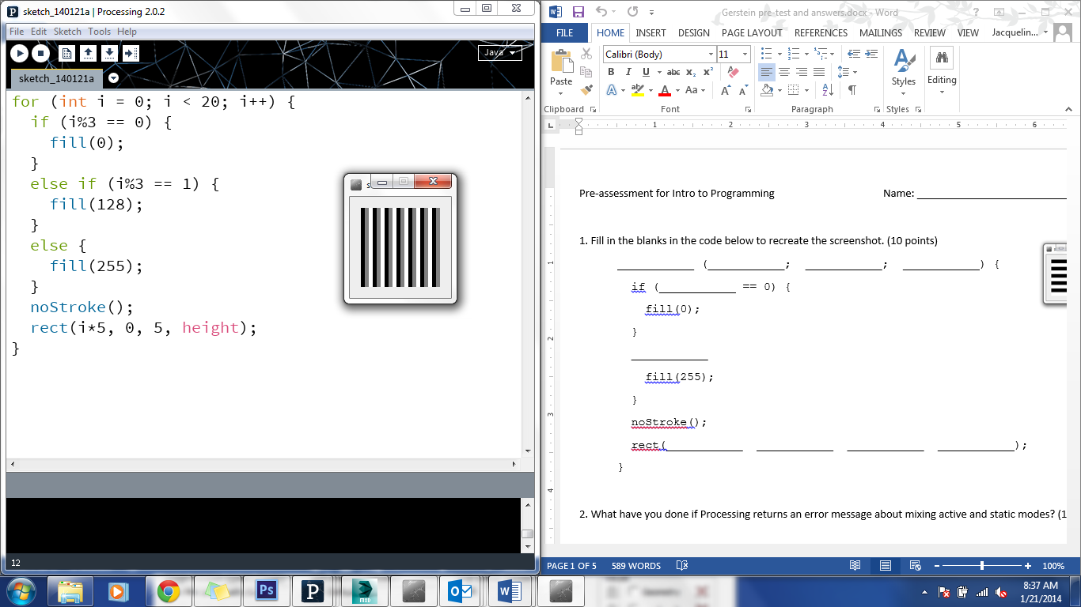Recreate the screenshot to the right using a for loop. Assume that the display area is 100 x 100 and that there are 20 stripes, each one 5 pixels wide. The stripes cycle between black, gray, and white fill.

Other things to think about: what if I were to ask you to do two colors? Four colors? Five? Keep in mind that if you have to specify each rectangle’s color individually, you’re doing it wrong.

1. Define the following functions:
   1. A function that, when called, will create a 50 pixel blue square in the center of the screen
   2. A function that, when called, will create a 10 pixel diameter red circle at a location specified when the function is called
   3. A function to convert from Fahrenheit to Celsius, which, when called, will return a float equal to the Celsius value of the number specified when the function was called
2. If I’ve created an ArrayList of objects of the “Bouncer” class, and the name of the ArrayList is “bouncers”, how can I refer to the size of that ArrayList? What if it were an array with the same name?
3. Create an array of float values containing the values 5.4, 3.9, 20.5, 100.2, and 56.8

Create an array of 5 objects of the Bouncer class. If the constructor for the Bouncer class takes no arguments, how would you write a for loop to initialize all the new Bouncers?

Create an ArrayList of objects of the Bouncer class. Write a line that adds one new Bouncer to the ArrayList

1. Assume you have an ArrayList named bouncers containing objects of the Bouncer class. Write a for loop to run through the entire array and run the “display” and “bounce” methods on each Bouncer.

Try starting at the beginning of the ArrayList and going to the end. Also try starting at the end and going to the beginning. Why would you do one as opposed to the other?

1. Remember Booleans? They haven’t gone away. Write a sketch in which each time a key is pressed, a circle in the middle of the screen changes between being filled with red and having no fill. Please note that this change should only happen once each time the key is pressed.

What if you had to do this with a rectangle? What if you had to limit it to when you click a mouse inside the rectangle or the circle?